5. Application Setup
The first step in developing ResolveIT was establishing an environment capable of running the ticket management system. The team used PHP, Apache, and Microsoft SQL Server to build a web-based application that allows employees to submit IT support requests and technicians to manage them. Each technology serves a different purpose within the application. Apache handles web requests, PHP processes information and controls application functionality, and SQL Server stores the data used throughout the system. Setting up these components provided the foundation for the remaining development tasks.
5.1 Development Environment and Application Structure
ResolveIT was developed using Apache HTTP Server 2.4, PHP 8.3, and Microsoft SQL Server. Apache was chosen to host the application and process requests from users accessing the website through a browser. PHP handles backend operations, including processing forms, retrieving information from the database, and determining what information users are allowed to access. Apache uses a DocumentRoot configuration to determine which files can be accessed through the web server (Apache Software Foundation, n.d.). In ResolveIT, this directory is set to public/, which contains the pages and resources that users interact with.
The project files are organized into separate directories based on their purpose. The app/ directory contains the shared PHP functions used for authentication, database connections, ticket processing, and validation. The public/ directory contains the browser-accessible PHP pages, CSS stylesheets, and JavaScript files. Additional folders include database/, which contains the SQL Server scripts, tests/, which stores testing procedures, and docs/, which contains project documentation. Keeping these files separated makes the application easier to organize and allows team members to work on different parts of the project without interfering with unrelated components. It also keeps configuration files and internal application logic outside the publicly accessible directory.
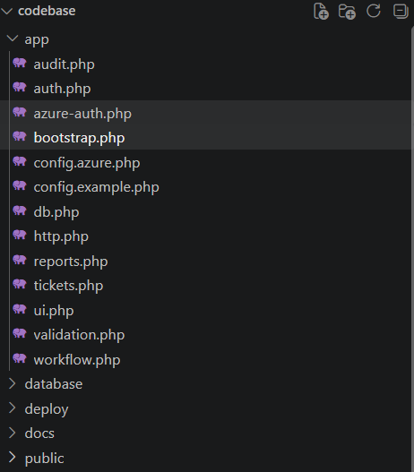

Figure 5.1 ResolveIT Application Folder Structure:
5.2 SQL Server Database Integration
Microsoft SQL Server was used to store and manage information throughout ResolveIT. The database contains 12 tables and 14 foreign-key relationships, which connect information such as user accounts, roles, support tickets, ticket statuses, priorities, technician comments, and ticket history. These relationships are important because a single ticket may involve information from several tables. For example, when a technician opens a support request, the application retrieves the ticket details along with information about the employee who submitted it, the technician assigned to the request, and any comments or changes that have been recorded.
The application communicates with SQL Server through PHP Data Objects (PDO) and Microsoft's SQL Server driver. The PDO interface provides a consistent way for PHP to send SQL statements and retrieve database records (Microsoft, n.d.). Database connectivity is managed through app/db.php, which allows the different pages to use the same connection functions rather than creating separate database connections. ResolveIT also uses prepared SQL statements when processing database queries. Prepared statements separate SQL commands from the values supplied by users, which helps reduce the risk of SQL injection attacks (The PHP Group, n.d.-b). This is especially important because employees and technicians regularly submit information through forms that must be saved to the database.
5.3 Application Startup and Deployment
The application uses app/bootstrap.php to initialize the resources needed for each page to function. This file loads the application configuration, connects to the database, starts the session, and includes the shared PHP modules. Having these functions load through one file reduces the amount of repeated code needed throughout the application and helps keep the different pages working consistently. The local development environment can be started using the PowerShell script start-site.ps1, which launches the Apache web server and makes the website available through a browser on port 8080.
The team also configured a Cloudflare tunnel to provide access to the locally hosted application through an HTTPS link. This allows other team members to review and demonstrate the website without having to install and configure the entire project on their own computers. The project also includes Docker and Microsoft Azure deployment configurations, although the Azure deployment has not been completed because of account access and authentication issues. The Apache environment and Cloudflare tunnel currently provide access to the working system for development and demonstrations.

Figure 5.3. ResolveIT Running Application
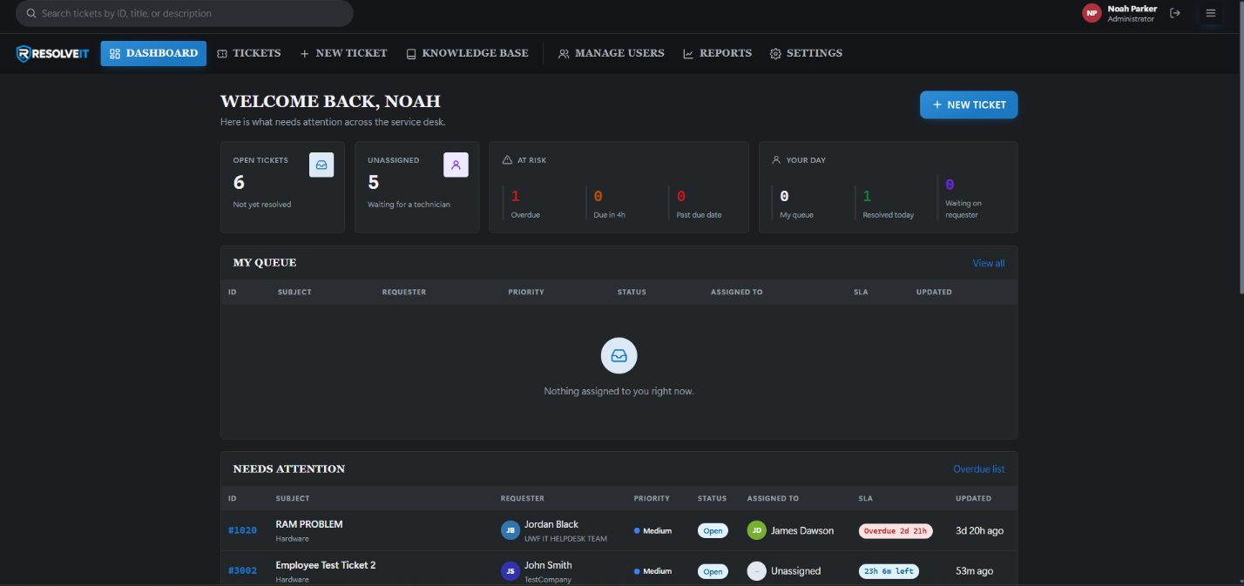
6. Login and User Access
ResolveIT includes a login system to identify users and control which parts of the application they are allowed to access. Because the system stores support requests, employee information, and technician activity, it is important that users cannot access information outside their assigned responsibilities. The application uses authentication to verify a user's identity and role-based access control to determine which pages and functions are available after login.
6.1 User Authentication
The login page is located in public/login.php and requires users to enter an email address and password. When the login form is submitted, the application checks the information against the user records stored in SQL Server. The authentication functions are located in app/auth.php, which handles password verification and maintains the authenticated user's information. If the credentials match an active account, the user is signed in and given access to the application based on their assigned role.
Passwords are not stored in readable form within the database. Instead, ResolveIT uses PHP's password hashing functions to securely store and verify passwords. The password_hash() function creates a password hash, while password_verify() compares the submitted password with the stored hash during login (The PHP Group, n.d.-a). If an incorrect email address or password is entered, the application displays a general error message without specifying which value was incorrect. This follows recommendations from OWASP, which advises against providing authentication errors that could help an attacker determine whether an account exists (OWASP Foundation, n.d.-a).
Figure X. ResolveIT Login Interface
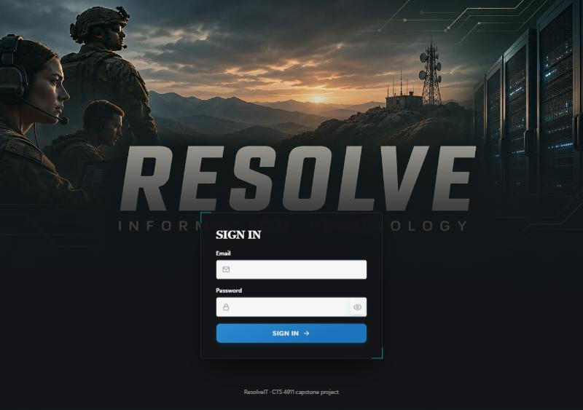
6.2 Login Protection and Session Management
Several security features were included to help protect user accounts from unauthorized access. ResolveIT records unsuccessful login attempts and temporarily blocks additional attempts when certain limits are reached. The application allows a maximum of five unsuccessful attempts for an email address within 15 minutes, along with an IP-based limit of 20 unsuccessful attempts during the same period. These restrictions help reduce the risk of someone repeatedly attempting to guess account passwords. Login throttling is one of the protections recommended by OWASP for preventing automated authentication attacks (OWASP Foundation, n.d.-a).
Once a user successfully logs in, PHP creates a session containing the user's ID, name, email address, and role. The application also regenerates the session identifier after login to help prevent session fixation attacks, where an attacker attempts to use an existing session identifier to gain unauthorized access (OWASP Foundation, n.d.-d). ResolveIT includes a 30-minute inactivity timeout in its local configuration. If the user remains inactive beyond that period, the session expires and they are required to sign in again. In addition, the application checks the user's account information during subsequent requests. This means that if an administrator changes a user's role, resets their password, or deactivates their account, the application can recognize the change without waiting for the user to log in again.
6.3 Role-Based Access Control
ResolveIT uses three user roles: Employee, Technician, and Administrator. Employees can submit support requests, view their own tickets, and communicate with technicians. Technicians have access to the ticket management features needed to investigate issues, assign support requests, update statuses, and document resolutions. Administrators have additional access to manage user accounts and system settings. Separating these responsibilities helps prevent users from accessing functions they do not need.
Access restrictions are handled through shared PHP functions such as require_login(), require_role(), and can_view_ticket(). These functions check whether a user is signed in and has the necessary permissions before allowing them to access a page or ticket. For example, an employee who attempts to open the administrator's user management page receives a 403 Forbidden response. The application also checks ticket ownership so that employees cannot view another employee's request by manually changing the ticket number in the URL. OWASP recommends enforcing access control on the server rather than relying only on hidden buttons or navigation links, since users may still attempt to access restricted pages directly (OWASP Foundation, n.d.-b).
Figure 6.3 Role-Based Navigation and Access
Top Image of 6.3 Show Role Based Access for Administrator
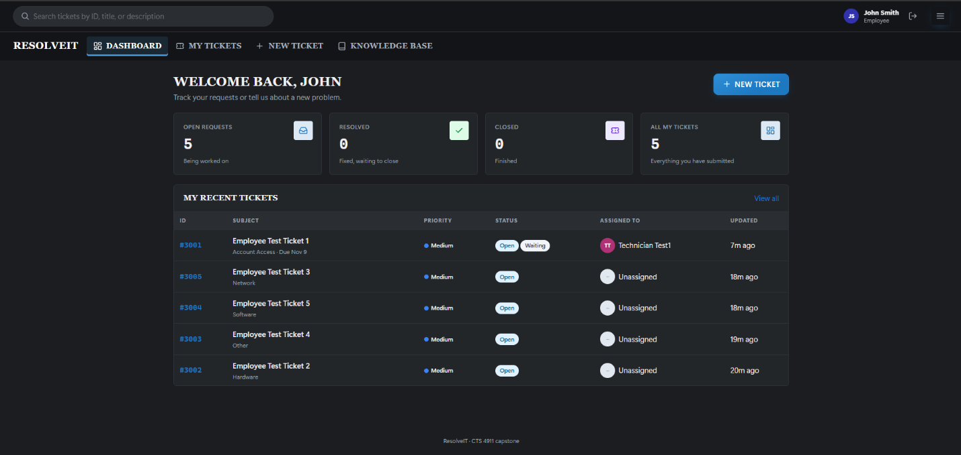
Bottom Image of 6.3 Show Role Based Access for Employees
7. Employee Ticket Pages
The employee ticket pages were developed to give users a central location for requesting IT assistance and checking the progress of their support requests. Instead of relying on emails or direct conversations with IT personnel, employees can submit a ticket containing the details of their problem and return to the website to see whether it has been assigned, worked on, or resolved. The employee interface includes ticket submission, ticket tracking, and communication features.
7.1 Employee Ticket Submission
Employees submit new IT support requests through public/ticket-create.php. The page contains a form that asks for a short title, a ticket category, and a description of the problem. The title is limited to 150 characters, and the description must contain between 10 and 5,000 characters. These requirements help prevent incomplete submissions and encourage employees to provide enough information for technicians to begin troubleshooting. The category field also allows the employee to identify the general type of problem, which helps organize requests within the system.
When the employee submits the form, PHP validates the entered information before saving it to SQL Server. The application automatically associates the new ticket with the employee's account, assigns it an Open status, and sets the initial priority to Medium. A ticket history entry is also created to document when the request was submitted. After submission, the employee can view the newly created ticket and monitor its progress. The page also includes a link to the Knowledge Base, giving employees the option to review troubleshooting articles before creating a support request. This may help users resolve common problems without needing assistance from a technician.
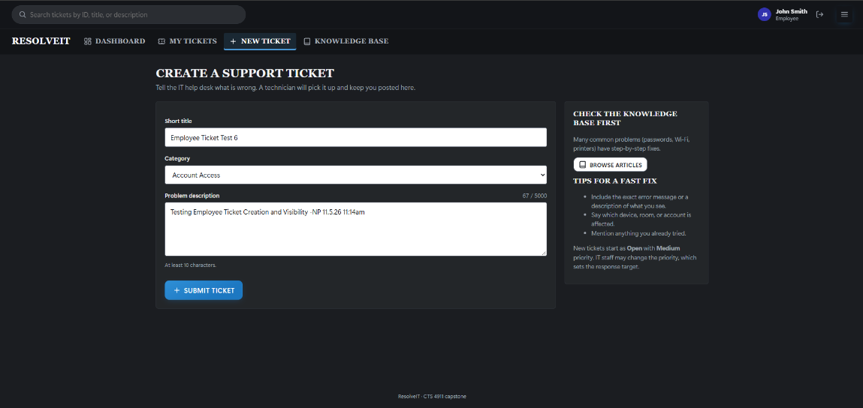
Figure 7.1 Employee Ticket Submission

7.2 Employee Dashboard and Ticket Tracking
The employee dashboard and public/tickets.php page allow users to view the support requests they have submitted. The ticket listing displays information such as the ticket number, subject, category, priority, assigned technician, and current status. Employees can search for specific tickets or use filters to narrow the results based on different ticket details. This makes it easier to locate an older request or check which issues are still being worked on without having to review every ticket individually.
One important part of the employee interface is that the application only retrieves tickets associated with the signed-in employee. Rather than displaying every ticket and hiding unrelated information on the webpage, the database query uses the authenticated user's ID to limit the records returned. This helps protect other employees' support information and ensures that users are only presented with the requests they are authorized to view. Having ticket information available through the dashboard also reduces the need for employees to contact IT personnel simply to request an update.
Figure 7.2 Employee Ticket Dashboard and Tracking
7.3 Ticket Details and Communication
When an employee selects a ticket, the application opens public/ticket.php, which displays more detailed information about the support request. This includes the original problem description, priority, assigned technician, current status, and any resolution information that has been entered. ResolveIT follows five ticket statuses: Open, Assigned, In Progress, Resolved, and Closed. The ticket details page includes a visual progress indicator so employees can see which stage their request has reached. This provides a clearer understanding of whether the ticket is waiting for assignment, actively being worked on, or completed.
The ticket details page also contains a conversation section where employees and technicians can communicate about the reported issue. Employees can answer questions, provide additional information, or review troubleshooting updates entered by the technician. Comments are saved in the ticket_notes table along with the author and timestamp, creating a record of the communication associated with each request. A separate ticket history section records events such as assignments and status changes. Once a ticket reaches Closed status, employees can still review the information, but additional comments can no longer be submitted through the normal ticket conversation.
Figure X. Ticket Details and Communication
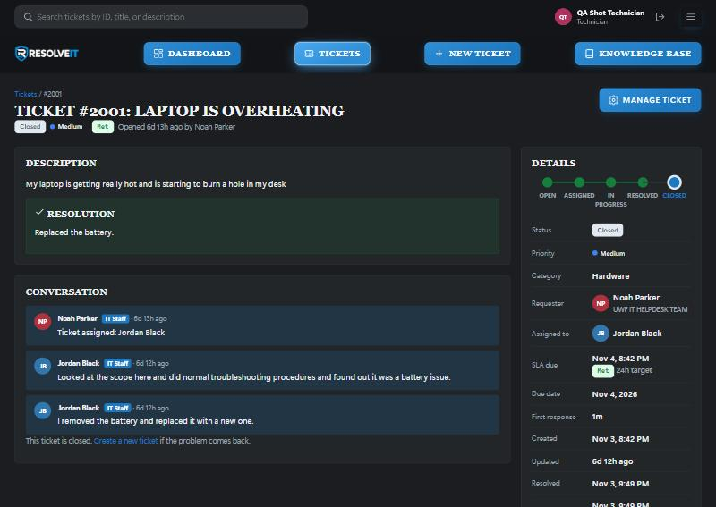
Figure X. Ticket Activity History
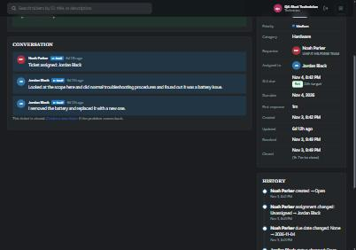

8. Technician and Administrator Pages
The technician and administrator pages provide the functions needed to manage support requests and maintain the application. While employees are primarily responsible for submitting tickets and providing information about their issues, technicians are responsible for reviewing those requests, troubleshooting problems, and recording resolutions. Administrators have additional responsibilities involving user accounts, permissions, and configuration settings. These pages use the same database and authentication system as the employee interface, allowing information to remain consistent across the different user roles.
8.1 Technician Dashboard and Ticket Queue
The technician dashboard provides an overview of the current support workload. It displays information such as open tickets, unassigned requests, overdue tickets, and tickets assigned to the technician currently logged in. This allows technicians to quickly identify outstanding work and determine which requests need attention. The dashboard also includes sections that highlight tickets approaching or exceeding their response targets, making it easier to recognize requests that may need to be prioritized.
The Tickets page provides a more detailed view of requests throughout the system. Technicians can search and filter tickets based on status, priority, category, assigned technician, or organization. Each ticket includes information about the requester, current status, and SLA target. Having these details available in one location helps technicians organize their workload and review incoming support requests without opening each ticket individually.
Figure 8.1 Technician Dashboard and Ticket Queue
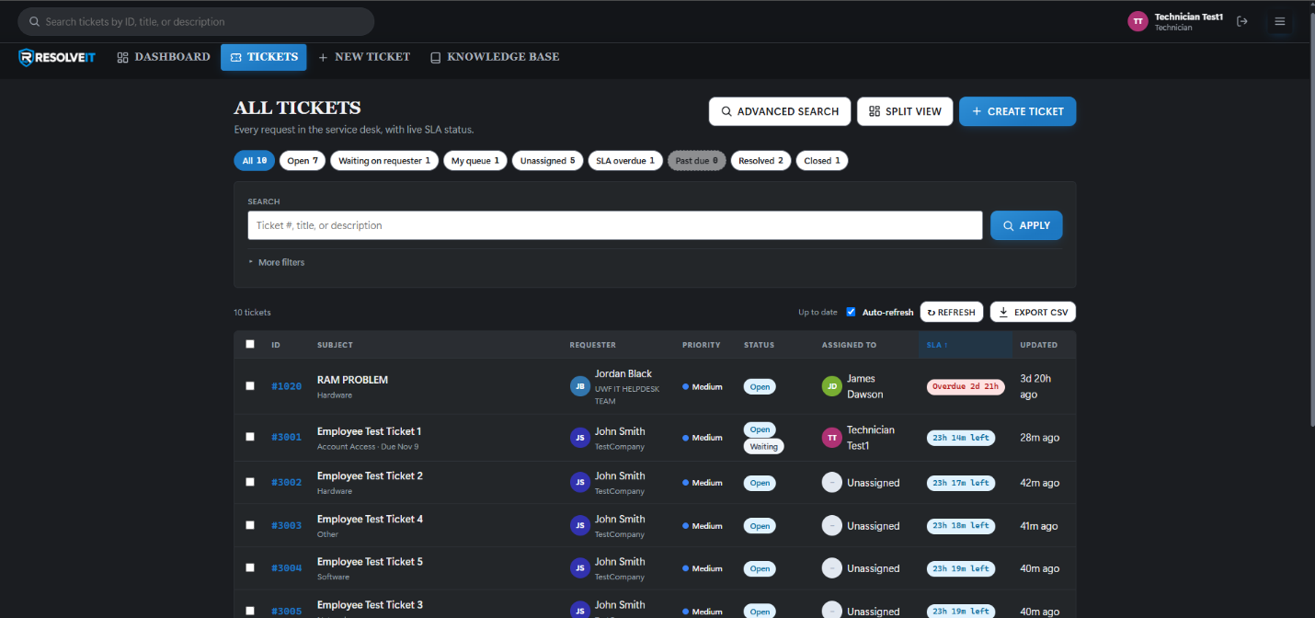
8.2 Ticket Assignment, Status Updates, and Resolution
Technicians manage individual support requests through public/ticket-edit.php. This page provides the controls needed to assign tickets to technicians, change priorities, update statuses, set due dates, enter troubleshooting notes, and document resolutions. Ticket changes follow rules defined in app/workflow.php, which helps prevent requests from moving through the support process incorrectly. The standard workflow starts with Open, followed by Assigned, In Progress, Resolved, and Closed.
The application includes several requirements for changing a ticket's status. A technician must be assigned before the ticket can advance beyond Open, and a resolution description containing at least 10 characters must be entered before the request can be resolved or closed. The system also allows a Resolved ticket to return to In Progress if additional troubleshooting is needed. Once a ticket reaches Closed status, it cannot be moved to another status through the normal workflow. When technicians save updates, the changes are stored in SQL Server and recorded in the ticket's history. These rules help maintain a consistent process for managing requests from submission to completion.

Figure 8.2 Technician Manage Ticket Page
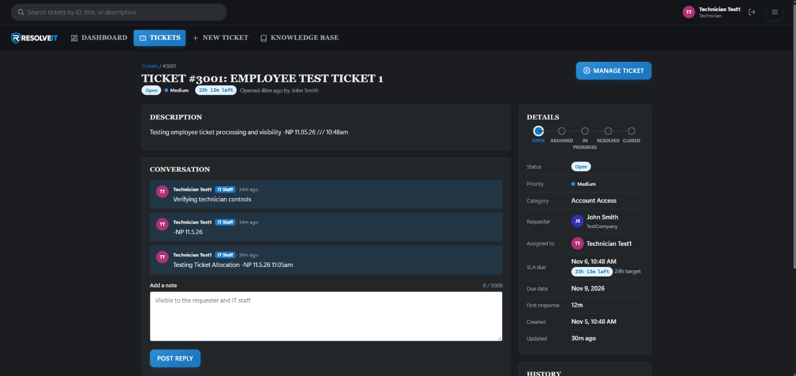
8.3 Ticket History and Accountability
ResolveIT keeps a record of ticket activity using the ticket_history and ticket_notes tables. The history table records changes such as technician assignments, priority updates, and status transitions, while the notes table stores troubleshooting comments and communication. These records are useful because support requests may involve multiple updates or require more than one technician to investigate the issue. Having previous actions available allows someone reviewing the ticket to understand what has already been attempted and what still needs to be completed.
Ticket #2001 provides an example of the ticket management process. The request involved a laptop overheating issue that was assigned to a technician for investigation. During troubleshooting, the technician identified a battery problem and documented the battery replacement as the resolution. The ticket history shows the request progressing through the different statuses until it was closed. This example demonstrates how the application maintains a record of ticket activity and the steps taken to resolve a reported problem.
8.4 Administrator User Management
Administrators have access to additional pages used to manage user accounts and permissions. The public/users.php page allows administrators to create new accounts, review existing users, and activate or deactivate accounts when necessary. Account information can also be changed through public/user-edit.php, which allows administrators to update names, email addresses, roles, organizations, and passwords. These functions provide a way to manage user access without requiring administrators to make changes directly within the SQL Server database.
The Manage Users page also includes filtering and sorting options to help locate accounts based on their roles, organizations, or activation status. For example, an administrator can filter the list to view technician accounts or identify users who are currently inactive. Access to these management functions is restricted to the Administrator role through the application's authentication system. Employees and technicians are prevented from accessing these pages because their assigned responsibilities do not require account management permissions.
Figure 8.4 Administrator User Management
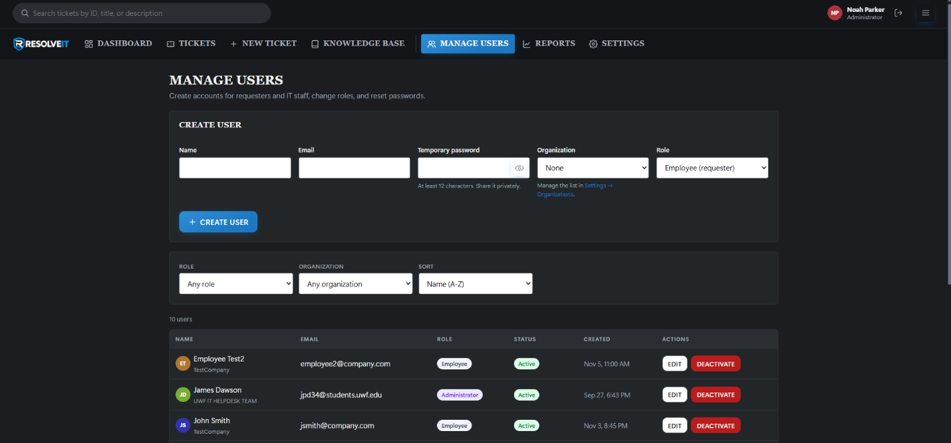

8.5 Administrator Settings
The administrator settings page, located in public/settings.php, provides options for managing several parts of the application. Administrators can add, rename, activate, or deactivate ticket categories and organizations. They can also update priority names and the SLA response targets associated with different priority levels. These settings allow the system to be adjusted as the organization's support needs change without requiring modifications to the PHP source code.
Some settings are intentionally restricted to prevent changes that could interfere with ticket processing. For example, the ticket statuses are displayed on the Settings page but cannot be edited because the application relies on their established order when validating ticket transitions. ResolveIT also maintains an administrative audit log that records changes involving user accounts and system settings. This provides a history of administrative actions and helps identify when configuration changes were made.
Figure X. Administrator Settings
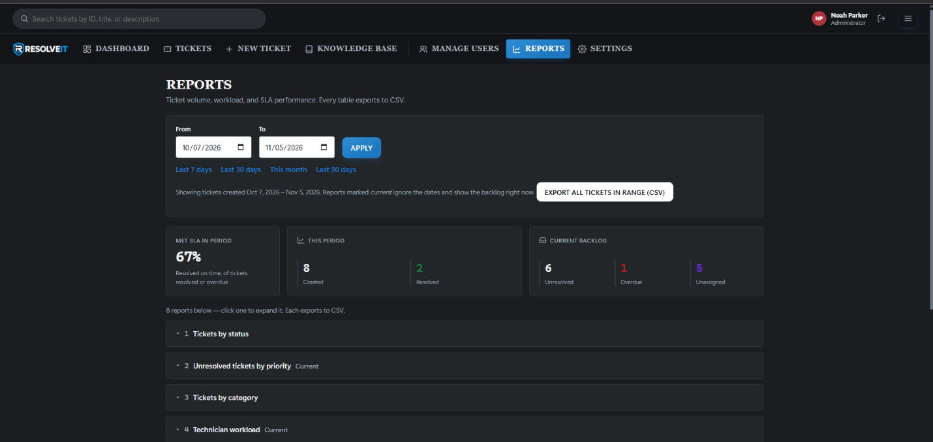
8.6 Integration of Application Components
The different parts of ResolveIT work together through a shared application structure. The Apache server and PHP environment provide the resources needed to run the website, while SQL Server stores the user accounts, tickets, comments, and history records. The authentication system identifies users and determines which functions they can access. Employees use the system to submit requests, technicians use the same records to investigate and resolve those requests, and administrators manage the accounts and settings that support the process.
Using shared PHP functions and database tables helps keep information consistent throughout the application. For example, when a technician updates a ticket's status, the change is saved to the database and becomes visible to the employee who submitted the request. Similarly, changes to user roles or account status are recognized by the authentication system during later requests. By connecting these components, ResolveIT provides a central location for handling IT support requests from initial submission through resolution.

References
Apache Software Foundation. (n.d.). Core – Apache HTTP Server version 2.4. https://httpd.apache.org/docs/2.4/mod/core.html
Microsoft. (n.d.). Microsoft Drivers for PHP for SQL Server. Microsoft Learn. https://learn.microsoft.com/en-us/sql/connect/php/microsoft-php-driver-for-sql-server
OWASP Foundation. (n.d.-a). Authentication cheat sheet. OWASP Cheat Sheet Series. https://cheatsheetseries.owasp.org/cheatsheets/Authentication_Cheat_Sheet.html
OWASP Foundation. (n.d.-b). Authorization cheat sheet. OWASP Cheat Sheet Series. https://cheatsheetseries.owasp.org/cheatsheets/Authorization_Cheat_Sheet.html
OWASP Foundation. (n.d.-c). Cross-site request forgery prevention cheat sheet. OWASP Cheat Sheet Series. https://cheatsheetseries.owasp.org/cheatsheets/Cross-Site_Request_Forgery_Prevention_Cheat_Sheet.html
OWASP Foundation. (n.d.-d). Session management cheat sheet. OWASP Cheat Sheet Series. https://cheatsheetseries.owasp.org/cheatsheets/Session_Management_Cheat_Sheet.html
The PHP Group. (n.d.-a). password_hash. PHP Manual. https://www.php.net/manual/en/function.password-hash.php
The PHP Group. (n.d.-b). PDO::prepare. PHP Manual. https://www.php.net/manual/en/pdo.prepare.php

